SQL Assignment 03

248518 Gaurav B Raskar

Q.29.

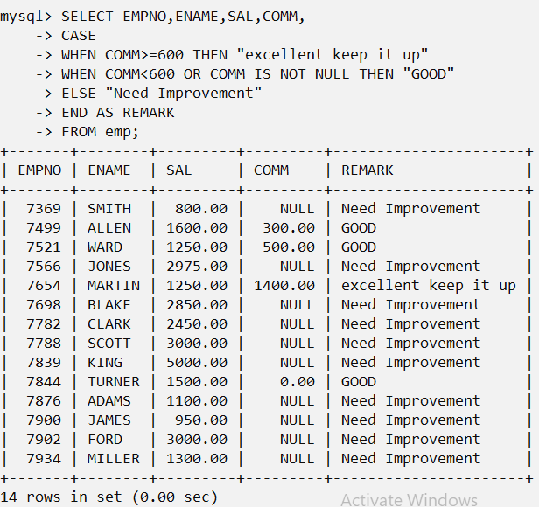

Q.30.

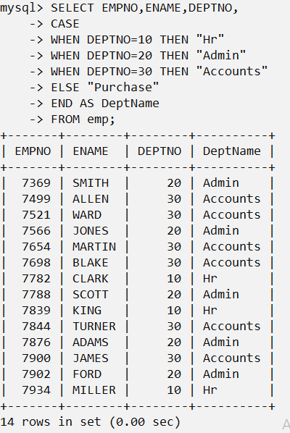

Create Tables Practice

Q.31.

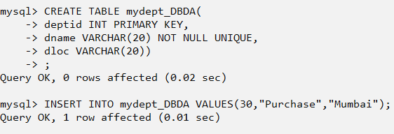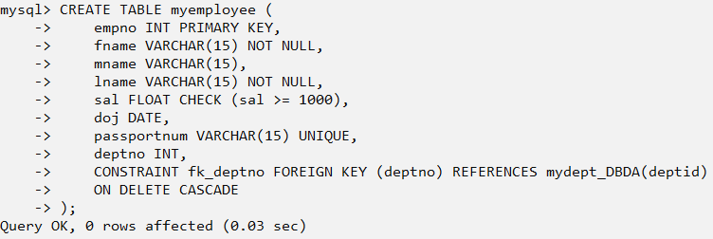

Q.32.

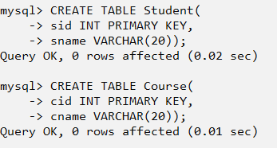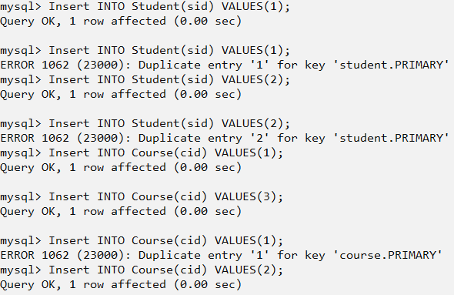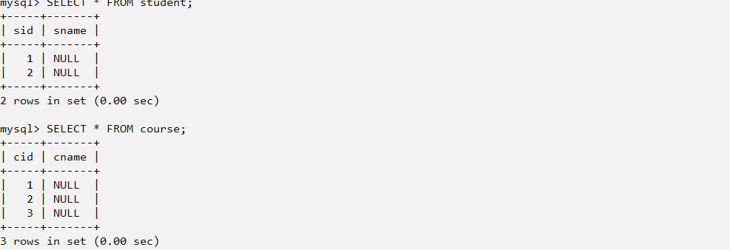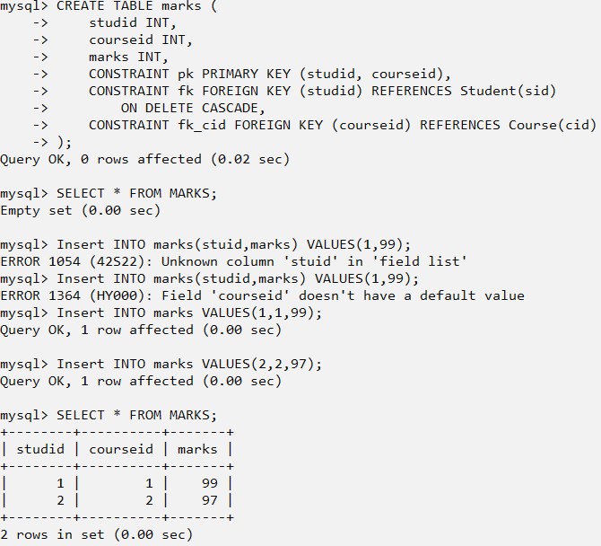

Q.33.

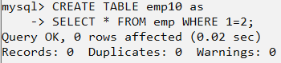

Q.34.

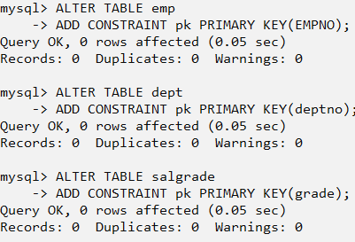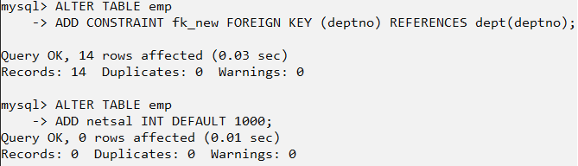

Q.35.

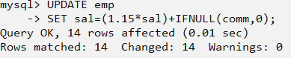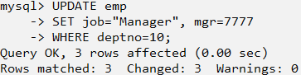

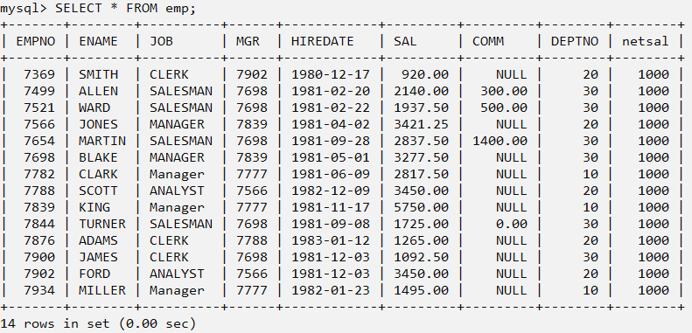

Q.36.

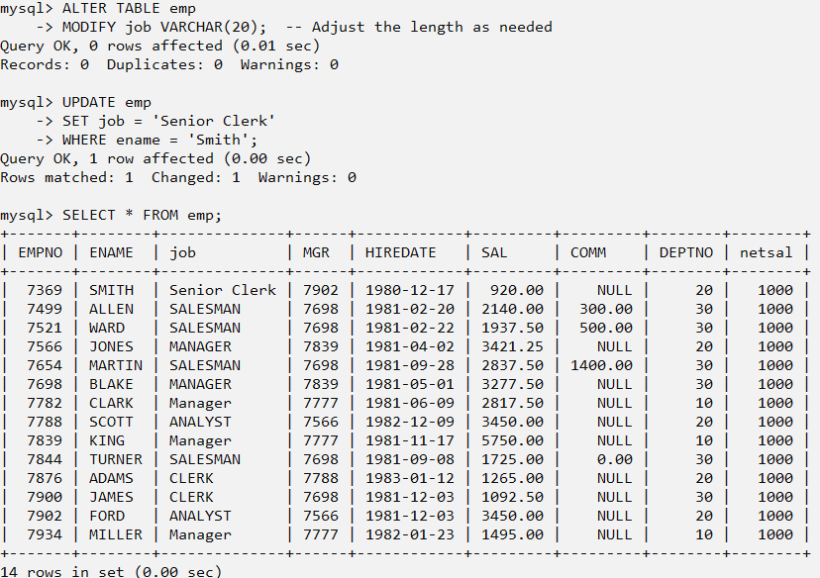

Q.37.

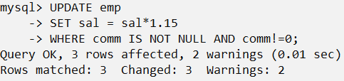

Q.38.

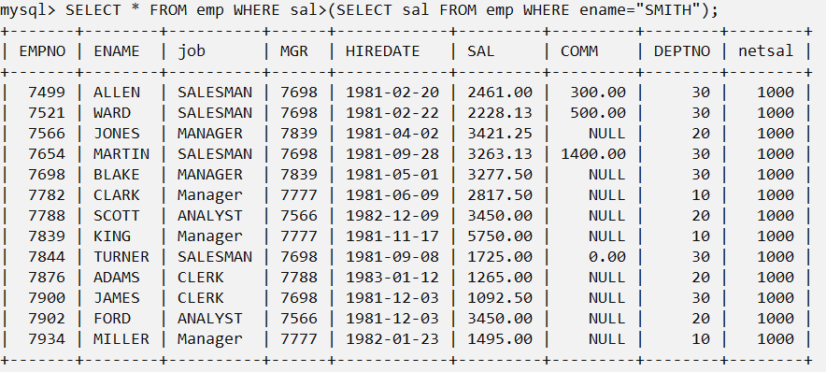

Q.39.

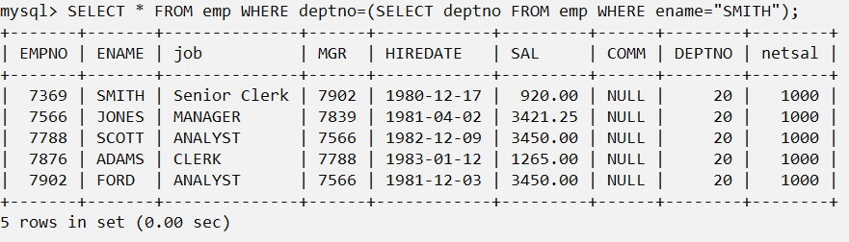

Q.40.

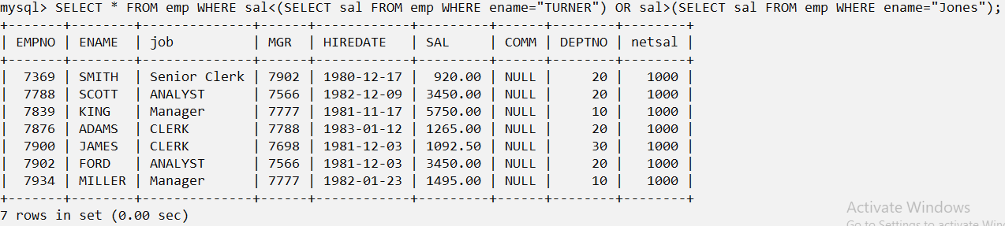

Q.41.



Q.42.

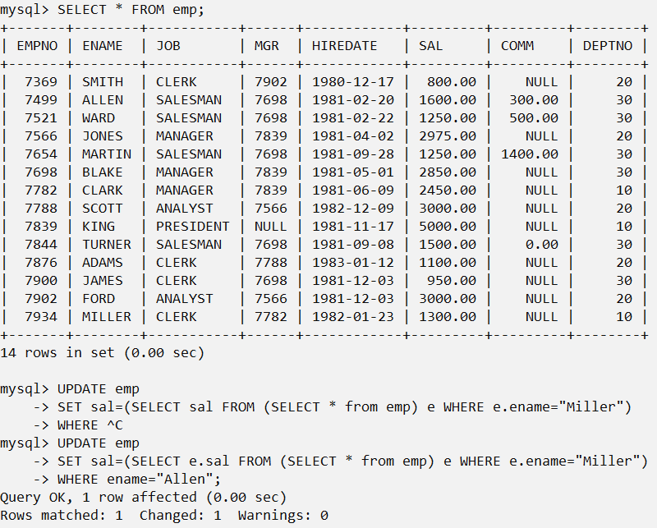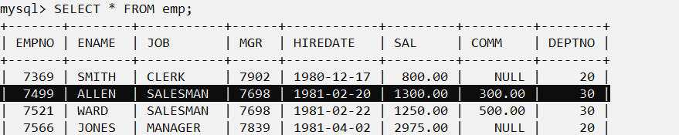

Q.43.

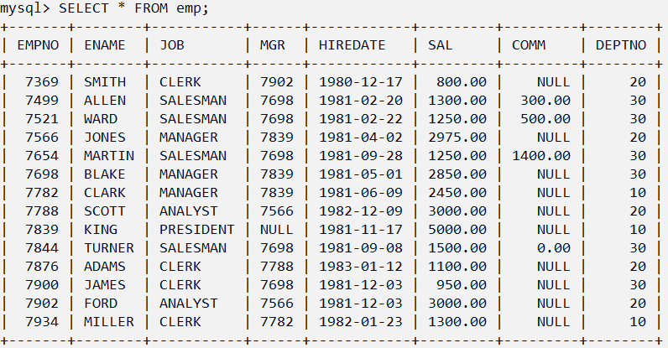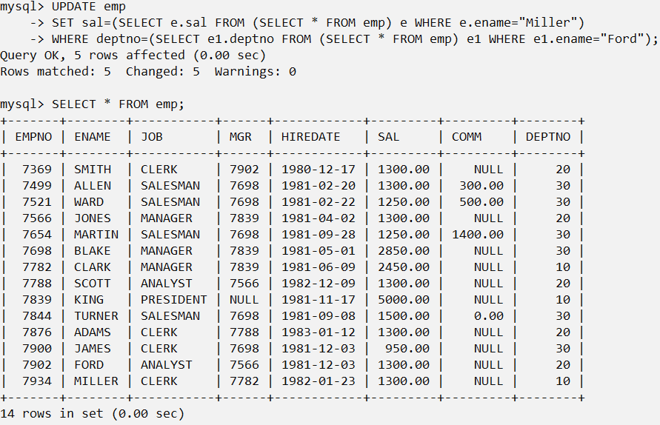

Q.44.

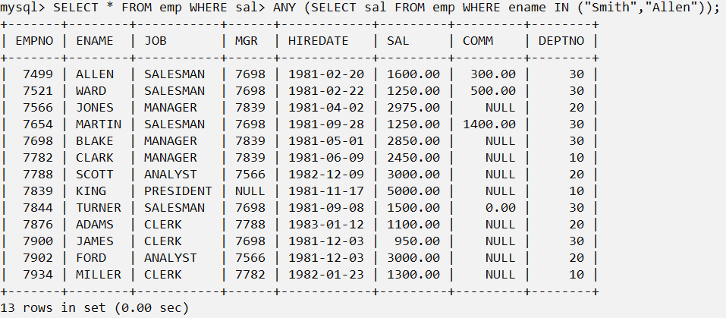

Q.45.

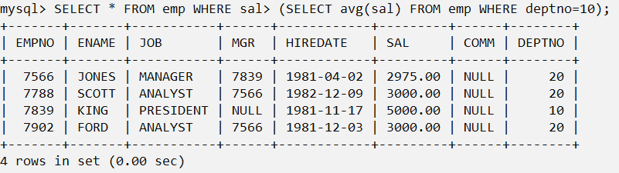

Q.46.

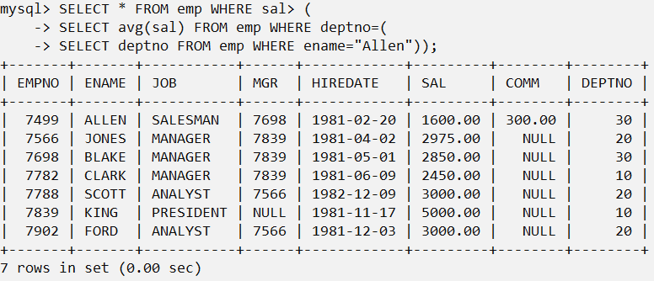

Q.47.

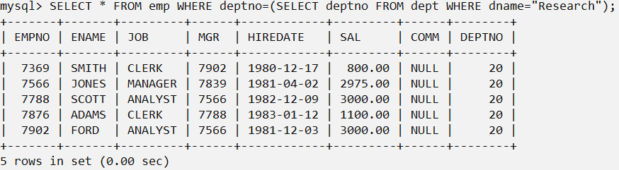

Q.48.

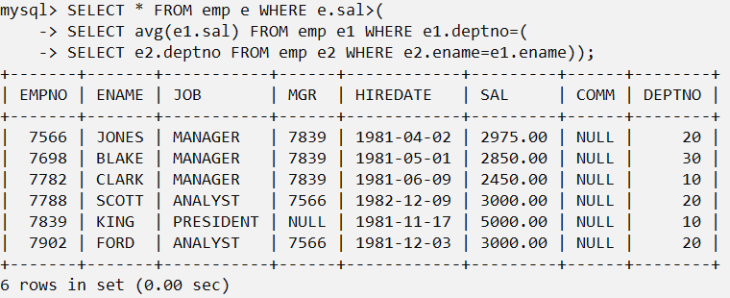

Q.49.

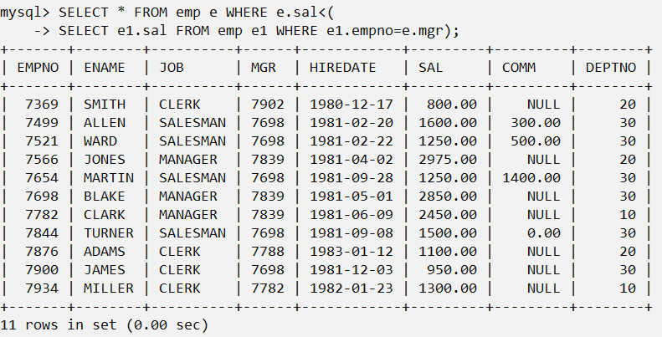

Q.50.

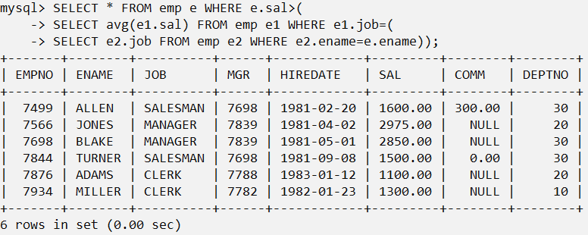

Q.51.

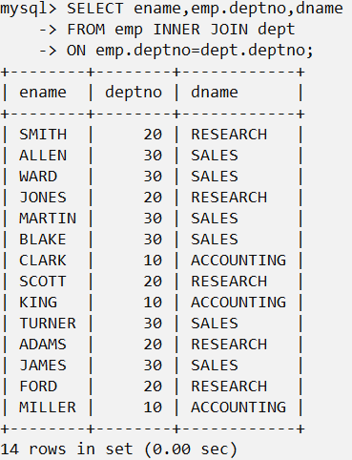

Q.52.

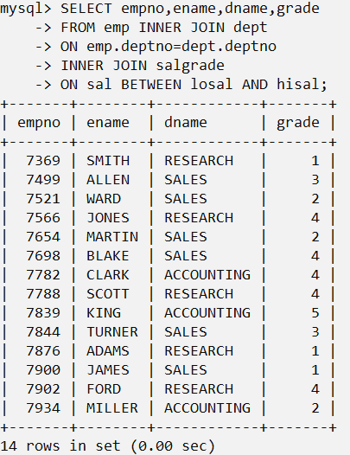

Q.53.

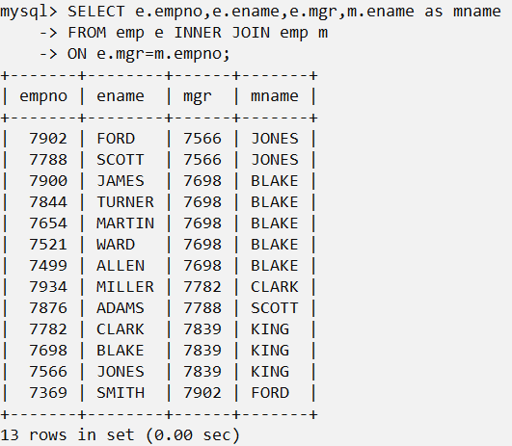

Q.54.

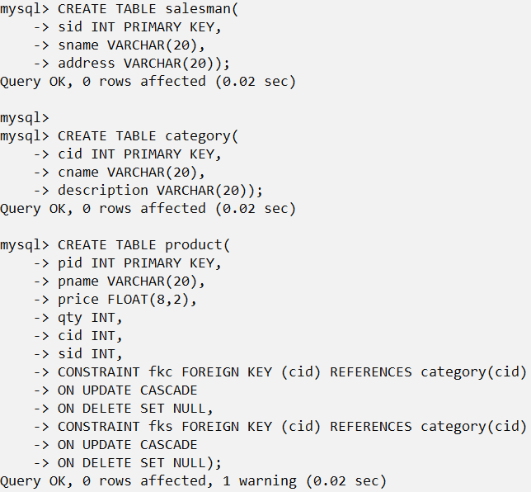

INSERT INTO category VALUES(11,"Chips","Potato");

INSERT INTO category VALUES(12,"Drinks","Soft");

INSERT INTO category VALUES(13,"milk","Dairy");

INSERT INTO salesman VALUES(101,"Jesse","Pune");

INSERT INTO salesman VALUES(102,"Walter","A.nagar");

INSERT INTO salesman VALUES(103,"Skyler","Mumbai");

INSERT INTO product VALUES(1,"Balaji",5.00,100,11,102);

INSERT INTO product VALUES(2,"Lays",10.00,99,11,102);

INSERT INTO product VALUES(3,"Pepsi",20.00,30,12,103);

INSERT INTO product VALUES(4,"Fanta",25.00,25,12,103);

INSERT INTO product VALUES(5,"Amul",35.00,20,13,101);

INSERT INTO product VALUES(6,"Chitale",36.00,25,13,101);

INSERT INTO product VALUES(7,"Gokul",34.00,15,13,101);

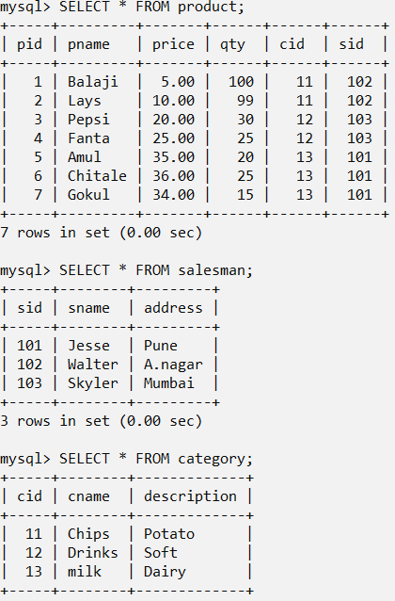

1)

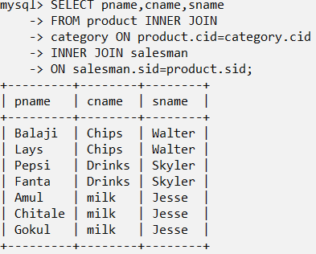

2)

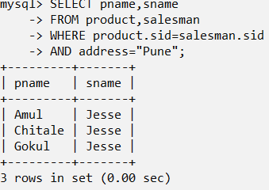

3)

